Taking an Accurate BP

Prepare Patient:
- Does patient have to empty bladder? If so, ask patient to use restroom first.
- Assess for any recent nicotine, caffeine consumption (can not delay visit but good to note)
- Patient sits quietly for 5 minutes prior to measurement

Patient Positioning
- Seated or semi-reclined; both feet flat on floor
- Bare arm (no clothing)
- Arm supported at heart level
- There should not be a gap between the cuff and arm – this means the arm is conical shaped and needs a conical upper arm or radial cuff
- Remind patient not to move arm or talk during measurement

Two ways to measure for proper fit:

- Measure arm circumference
- Measure the length of arm from shoulder bone to elbow bone
- Half the length and measure circumference at this location in centimeters
- Reference circumference measurements on BP cuff to choose the correct cuff
- Thigh cuff can be used on upper arm if fit is appropriate

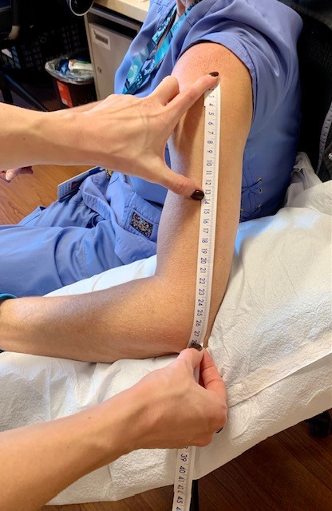

- Index line
- Each BP cuff has two range lines and an index line
When applied the index line must fit inside the two range lines

Size Chart
Dynomap – blue machine
Best for cylindrical arm shape
Small Adult | 17-25 cm
Adult | 23-33
Adult Long | 23-33
Large Adult | 31-40
Thigh | 38-50

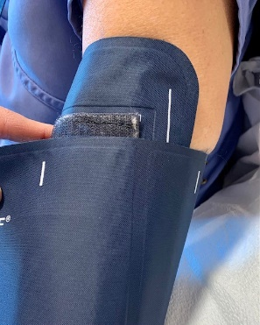

Omron – all blue cuffs
Best for conical arm shape
17-22 cm
22-32
32-42
42-50

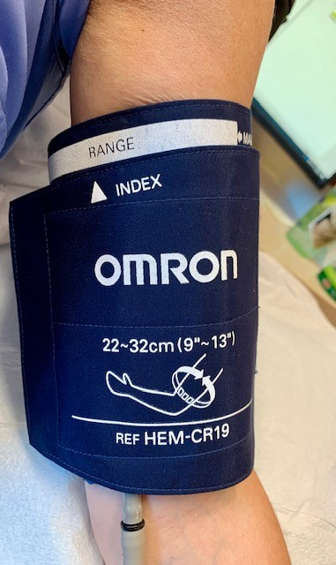

Radial Cuffs
To be used when:
- Upper arm circumference is >50 cm
- Arm is conical shape and gap is created between cuff and arm near elbow
- Upper arm is shorter than width of cuff

- Index lines and measuring forearm circumference for selecting best fit
- Connecting tubes pointed up toward elbow

Forearm circumference
26-36 cm

