

**Preterm Prelabor Rupture of Membranes of a singleton 34 0/7 to 36 6/7 weeks gestation**



**PURPOSE**

**To provide a guideline for counseling and management of singleton pregnancy with preterm prelabor rupture of membranes (PROM) from 34 0/7 to 36 6/7 weeks gestation.**

**Summary:**

* In March 2020 American College of Obstetricians and Gynecologists (ACOG) updated the recommendations for preterm PROM to allow for expectant management in this population.1
* This guideline applies to both women who experience preterm PROM prior to 34 weeks and reach 34 weeks gestation as well as those who experience preterm PROM between 34 0/7 to 36 6/7 weeks gestation.
* **Expectant management is never acceptable in a patient with chorioamnionitis (Triple I), non-reassuring fetal testing, or abruption.**
* Patients pregnant with twin or other multiple pregnancies are not considered candidates for expectant management.
* Patients should be counseled regarding:
  + Expectant management vs immediate delivery –benefits and risks
  + Late preterm steroids (not applicable if patient received earlier in the pregnancy)
* Patients who desire expectant management should be given latency antibiotics, at the same doses that are given to those prior to 34 weeks.
* Screening should be performed on presentation for preterm PROM for:
  + Gonorrhea, chlamydia, trichomonas, bacterial vaginosis, yeast, and group B streptococcus (GBS)
  + If any of the above tests return positive, we recommend proceeding with immediate delivery by appropriate obstetric route.
  + If the patient was positive for GBS at any point in pregnancy, expectant management should not be offered or recommended after 34 weeks.

**Points for discussion in patient counseling:**

* All preterm PROM between 34 0/7 to 36 6/7 weeks gestation is recommended to be managed as an inpatient hospitalization.
* If there are signs of chorioamnionitis (Triple I) then expectant management is ***not*** recommended and it is recommended to proceed with immediate delivery.
* The median days a patient remained pregnant in the expectant management group was 4 days.
* There are benefits and risks to both immediate delivery and expectant management (Table 1).2
* There are benefits and risks to steroids between 34 0/7 to 36 6/7 weeks gestation
  + Steroids should not be given 34 0/7 to 36 6/7 if previously given in the pregnancy
  + For other guidance regarding late preterm steroids, see MomBaby guideline: <https://www.mombaby.org/wp-content/uploads/2016/05/ASC-rev-4-25-2016-Reformatted-1.pdf>

**Table 1**: Benefits of expectant management and those of immediate delivery for preterm PROM 34 0/7 to 36 6/7 weeks gestation2

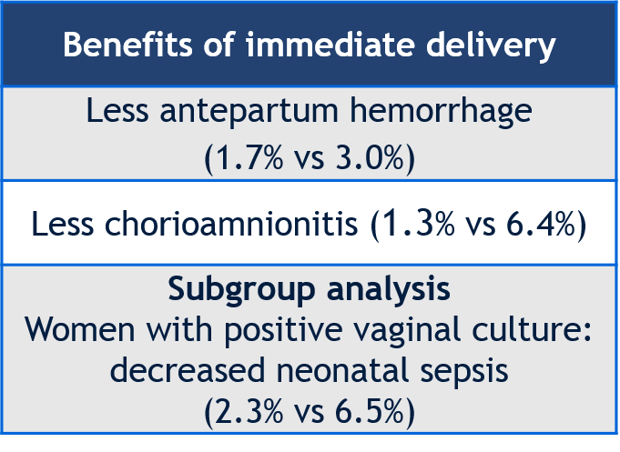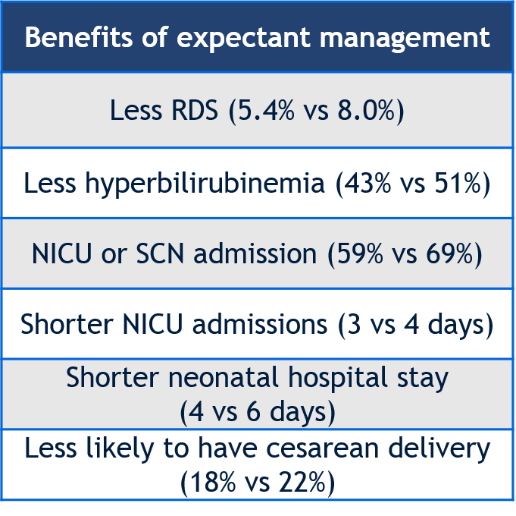

**Screening for Genitourinary Infections:**

* Screening should be performed on presentation for preterm PROM for:
  + Gonorrhea, chlamydia🡪 via vaginal PCR or urine PCR
  + Bacterial vaginosis, yeast, trichomonas 🡪 generally vaginitis screen
  + Group B streptococcus (GBS) 🡪 culture
* If the result returns positive for any of the above pathogens, and the patient has opted for expectant management, then we recommend treatment with appropriate antibiotics and moving towards immediate delivery
  + Mode of delivery is according to routine obstetric indications; positive vaginal cultures for any of the above pathogens is not an indication for cesarean
* Asymptomatic or symptomatic urinary tract infection is not an indication for recommending immediate delivery
* GBS colonization at any point in pregnancy, whether through urine culture or through GBS rectovaginal culture
* A uncomplicated UTI or positive urine culture for organisms other than GBS is not an indication for immediate delivery

**Latency Antibiotics**

* If a patient is <34 weeks at time of rupture and has already received latency antibiotics, they should **not** be repeated.
* Within the largest randomized controlled trial (RCT) regarding management of preterm PROM 34 0/7 to 36 6/7 weeks gestation 86% of patients in the expectant management group received some form of latency antibiotics.3 Similarly within the largest meta-analysis on the topic, 78% of patients were given antibiotics in the expectant management group.2
* While an RCT regarding dosing of antibiotics in this patient population has not been performed, it is reasonable to administer the same latency antibiotics as are administered prior to 34 weeks.

**References and Citations:**

1. Prelabor rupture of membranes. ACOG Practice Bulletin 217. Obstet Gynecol 2020:135;e80-97.
2. Quist-Nelson J, de Ruigh A, Seidler AL, et al. Immediate delivery compared to expectant management in late preterm prelabor rupture of membranes, an individual participant data meta-analysis. Obstet Gynecol 2018;131:269-79.
3. Morris JM, Roberts CL, Bowen JR et al. Immediate delivery compared with expectant management after preterm pre-labour rupture of membranes close to to term (PPROMT trial): a randomized controlled trial. Lancet 2015, e1-9.

***These algorithms are designed to assist the primary care provider in the clinical management of a variety of problems that occur during pregnancy. They should not be interpreted as a standard of care, but instead represent guidelines for management. Variation in practices should take into account such factors as characteristics of the individual patient, health resources, and regional experience with diagnostic and therapeutic modalities.***

***The algorithms remain the intellectual property of the University of North Carolina at Chapel Hill School of Medicine. They cannot be reproduced in whole or in part without the expressed written permission of the school.***

[www.mombaby.org](http://www.mombaby.org)

Revised October 26, 2020/JQN